**Ideation Phase**

**Empathize & Discover**

|  |  |
| --- | --- |
| Date | 21September 2022 |
| Team ID | PNT2022TMID03607 |
| Project Name | Corporate Employee Attrition Analytics |
| Maximum Marks | 4 Marks |

**Empathy Map :**

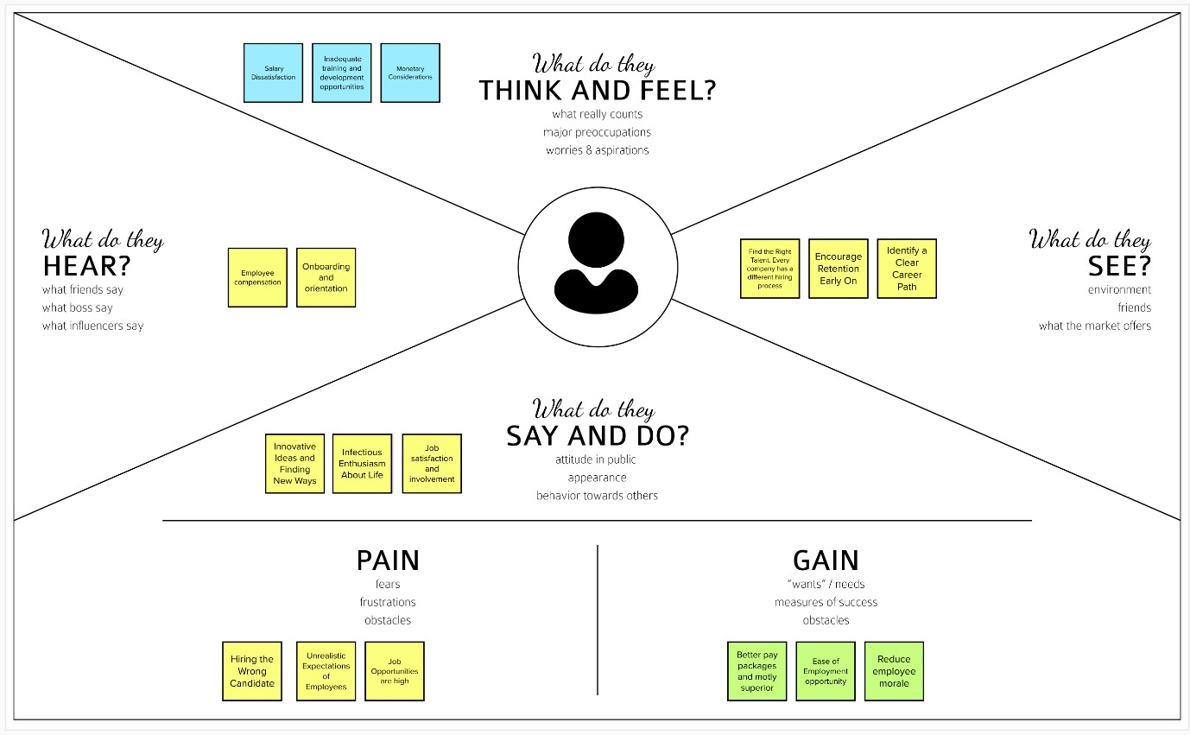

**Reference link :**

https://app.mural.co/t/thiruveni6684/m/thiruveni6684/1663828333678/ce886a6d32bcc1fc

84d3b43be38c9fcd59b6a7a0?sender=uae83de0b6881a8b180d75529